**Black Friday Sales Analysis**

**using various classifiers and regressors**

**Abstract**

During the Black Friday sale, all the retail shops are crowded. Most products are marked down with discounts and customers rush in to buy the products. It is difficult for customers to buy the products even with a solid plan.

But, the shop owners face even more difficulty on controlling the crowd with limited staff and in targeting prospective customers. Several techniques have been employed to tackle this problem, but they are not that successful. A prediction model is a technique that has proved promising in solving the problem.

We focus on the field of prediction models to develop an accurate and efficient algorithm to analyse the customer spending in the past and output the future spending of the customers with same features.

Different machine learning techniques such as regression and neural network to develop a prediction model are implemented and a comparison is done based on their performance and accuracy of prediction. These techniques are implemented using different algorithms to find the best predication.

We implemented six different machine learning algorithms. Further, we apply the data pre-processing and visualization techniques to attain the optimal results.

**Keywords:** Black Friday Sales, Prediction model, Regression, Neural network, Machine Learning

1. **Introduction**

In the past, there were no supermarkets or departmental stores, only small businesses. The store owners knew their customers and their spending patterns, their likes and their dislikes. But as the small business grew into large franchises with hundreds of stores across the country, it became near to impossible to know the customers and their personal preferences. Some examples of such franchises are Costco, Walmart, and Wholefoods.

These stores without any proper knowledge of their customer base are struggling to satisfy the customer needs. Thus, prediction models are needed to better understand customer preferences

Building a prediction model depends on various features such as the location and the time. Black Friday is the largest shopping day of the year in United States of America. Black Friday is the day after Thanksgiving Day which marks the beginning of the shopping season for Christmas.

A prediction model developed for Black Friday can only be used during that day because customer spending differs drastically between a normal day and a Black Friday; this is because discounts and price reductions attract more customers.

Finally, better visualization techniques are required to portray the findings and help the store owners understand their customers.

**Problem statement**

Can an accurate prediction model be developed?

Which algorithm is better and efficient for such model?

Will data pre-processing and visualization technique increase the accuracy?

1. **Literature survey**

Regression analysis is a form of predictive modelling technique which investigates the relationship between a dependent (target) and independent variable (predictor) This technique is used for forecasting, time series modelling and finding the causal effect relationship between the variables. The shape of regression line, the type of dependent variable and number of independent variable.

1. **Linear Regression**

Linear Regression establishes a relationship between dependent variable (Y) and one or more independent variables (X) using a best fit straight line (also known as regression line). It is represented by an equation Y=a+b*X + e, where a is intercept, b is slope of the line and e is error term. This equation can be used to predict the value of target variable based on given predictor variable(s).

1. **Ridge Regression**

Ridge Regression is a technique used when the data suffers from multicollinearity (independent variables are highly correlated). In multicollinearity, even though the least squares estimates (OLS) are unbiased, their variances are large which deviates the observed value far from the true value. By adding a degree of bias to the regression estimates, ridge regression reduces the standard errors.

1. **Decision Tree**

Machine learning algorithms like decision tree and regression are used for developing a simple yet efficient prediction models. Guo et al. state that a time series analysis using early purchase patters can be used to predict the future spending. The technique involved can be classified into two groups, mathematical and statistical model, and artificial intelligence model

1. **XGBoost**

The XGBoost model internally implements the stepwise, ridge regression which dynamically selects the features and removes the multi-collinearity with the features. This implementation gave the bet results of this dataset. It uses ensemble model to learn from the weak predictors and eliminate the less important features to develop a strong model.

1. **Random forest**

Random forest is an ensemble learning method for classification, regression and other tasks that operates by constructing a multitude of decision trees at training time and outputting the class that is the mode of the classes (classification) or mean prediction (regression) of the individual trees. Random decision forests correct for decision trees' habit of overfitting to their training set.

The major problem with the existing prediction model is that the data used for development contains several irregularities such as missing values or wrong information. Also, selection of right algorithm plays a major role in developing an accurate model.

1. **Proposed system**

Our system involves the application of machine learning techniques to predict the testing values in 4 steps-

1. **Data analysing**

In this stage we will just analysis various components of our data like mean, median, standard deviation, frequency etc. Also, we’ll find skew, kurtosis followed by correlation matrix with respect to Purchase values.

1. **Data pre-processing**

This stage will involve calculating all the NA values and replacing them with some integer so that processing can be carried out. Later we can also display the unique value frequencies of all the columns and finally send this data into a modified train and test csv files.

1. **Machine learning techniques**

After pre-processing the data, we will use the modified train and test files to apply the above given algorithms to find which is the best algorithm to calculate the purchase values by calculating the minimum rmse values.

1. **Rule Based Learning**

At the end we will apply rule-based learning to get the best possible rules and apply them to the dataset and finally apply it to the best obtained algorithm to get the perfect rmse scores.

**Dataset Used-**

Our dataset is the Black Friday Sales Dataset in Kaggle. In this dataset we have the information about the Age, Occupation, City, Duration stayed, Marital status, the quantity of products bought of various types and the total amount spent. We are using these inputs to find the most necessary attributes, potentially excluding some attributes. Finally, we arrive at the conclusion from applying these models to find which model is best suited to predict Purchase trend of customers.

**Train.csv**

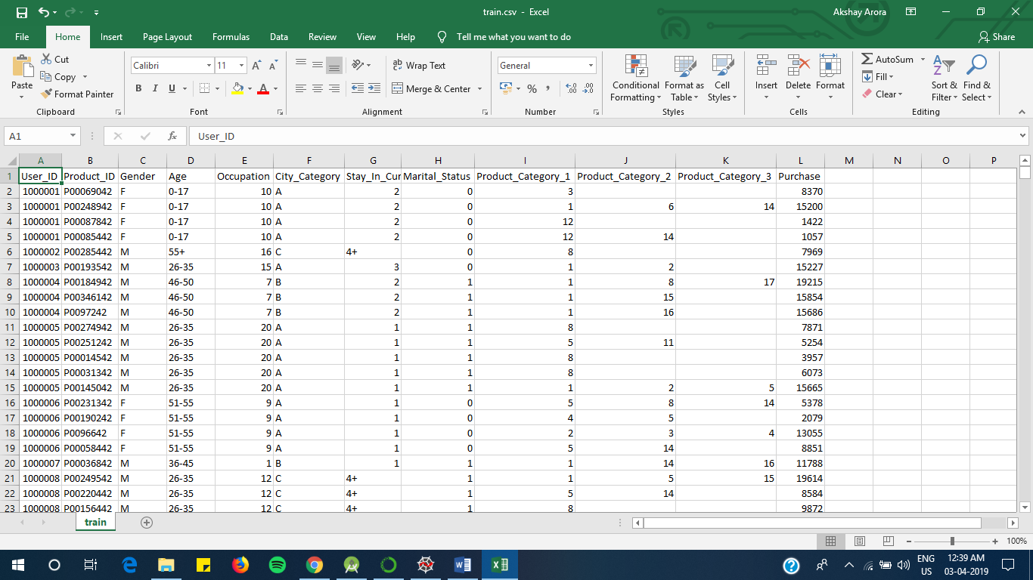

**Test.csv (No Purchase Values)**

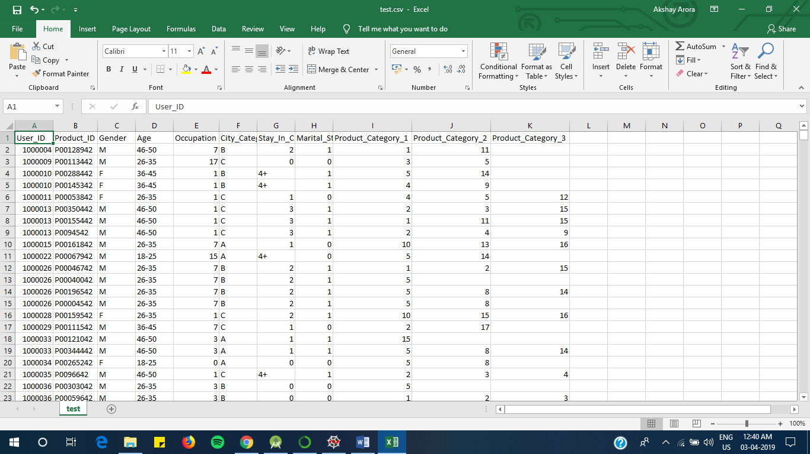

**4. Proposed System Analysis**

**Data Analysing**

In this step we just use common descriptive statistics techniques and apply them on our existing data like mean, median, standard deviation, frequency etc. Also, we’ll find skew, kurtosis followed by correlation matrix with respect to Purchase values.

The output obtained from the given codes in the appendix is-

User_ID Product_ID Gender Age Occupation City_Category \

0 1000001 P00069042 F 0-17 10 A

1 1000001 P00248942 F 0-17 10 A

2 1000001 P00087842 F 0-17 10 A

3 1000001 P00085442 F 0-17 10 A

4 1000002 P00285442 M 55+ 16 C

Stay_In_Current_City_Years Marital_Status Product_Category_1 \

0 2 0 3

1 2 0 1

2 2 0 12

3 2 0 12

4 4+ 0 8

Product_Category_2 Product_Category_3 Purchase

0 NaN NaN 8370

1 6.0 14.0 15200

2 NaN NaN 1422

3 14.0 NaN 1057

4 NaN NaN 7969

User_ID Occupation Marital_Status Product_Category_1 \

count 5.500680e+05 550068.000000 550068.000000 550068.000000

mean 1.003029e+06 8.076707 0.409653 5.404270

std 1.727592e+03 6.522660 0.491770 3.936211

min 1.000001e+06 0.000000 0.000000 1.000000

25% 1.001516e+06 2.000000 0.000000 1.000000

50% 1.003077e+06 7.000000 0.000000 5.000000

75% 1.004478e+06 14.000000 1.000000 8.000000

max 1.006040e+06 20.000000 1.000000 20.000000

Product_Category_2 Product_Category_3 Purchase

count 376430.000000 166821.000000 550068.000000

mean 9.842329 12.668243 9263.968713

std 5.086590 4.125338 5023.065394

min 2.000000 3.000000 12.000000

25% 5.000000 9.000000 5823.000000

50% 9.000000 14.000000 8047.000000

75% 15.000000 16.000000 12054.000000

max 18.000000 18.000000 23961.000000

There are 544177 duplicate IDs for 550068 total entries

Skew is: 0.6001400037087128

Kurtosis: -0.338378

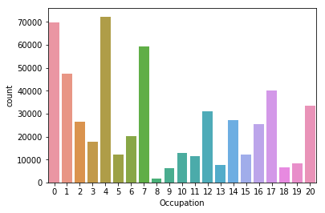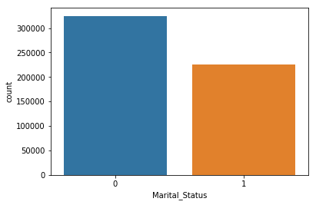

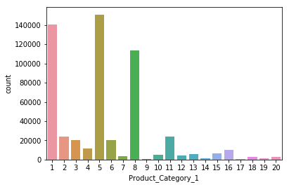 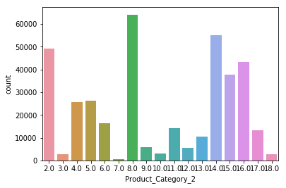

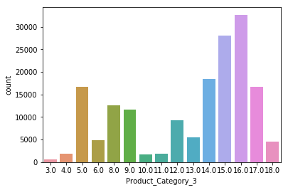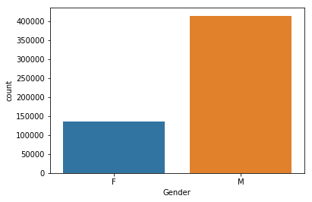

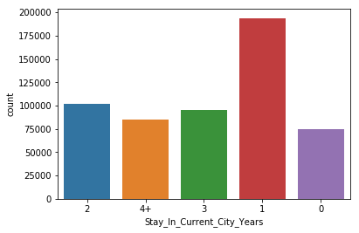 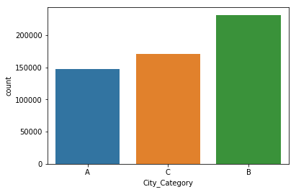

Correlation from Purchase

Purchase 1.000000

Occupation 0.020833

User_ID 0.004716

Marital_Status -0.000463

Product_Category_3 -0.022006

Product_Category_2 -0.209918

Product_Category_1 -0.343703

Name: Purchase, dtype: float64

Correlation Matrix

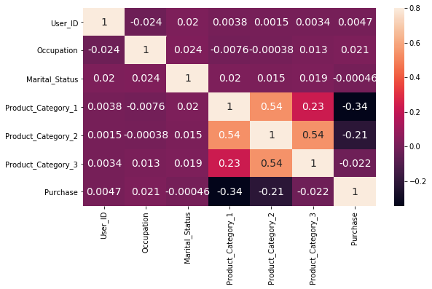

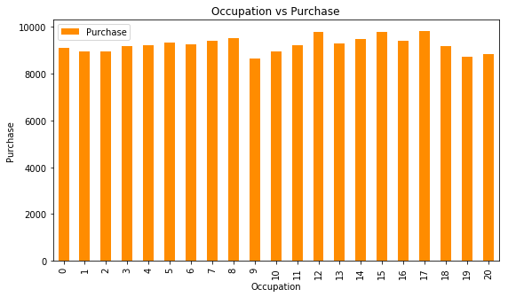 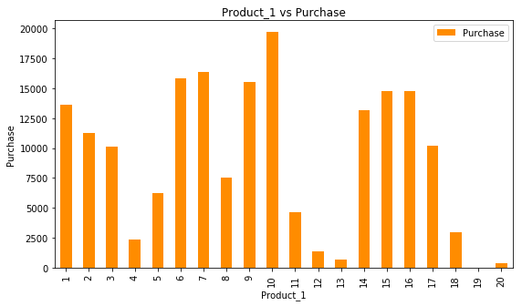

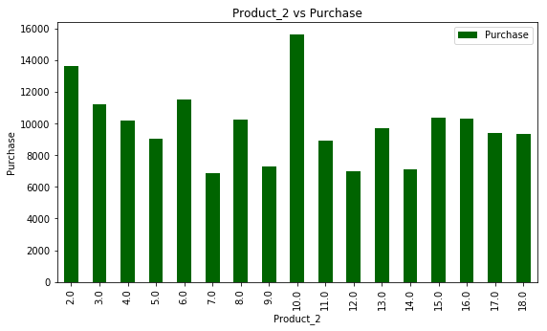 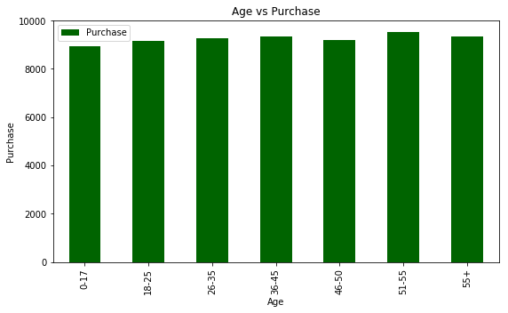

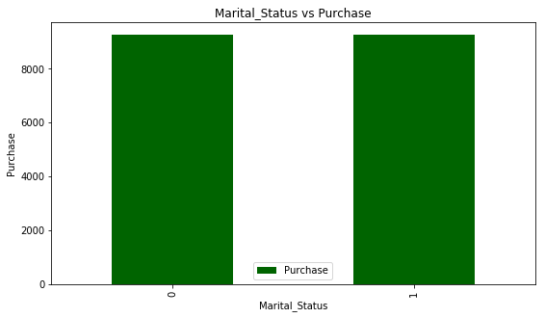 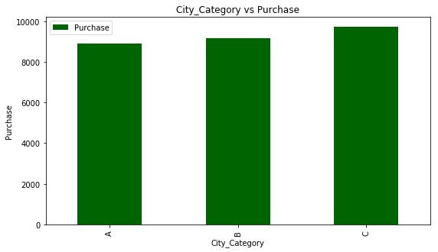

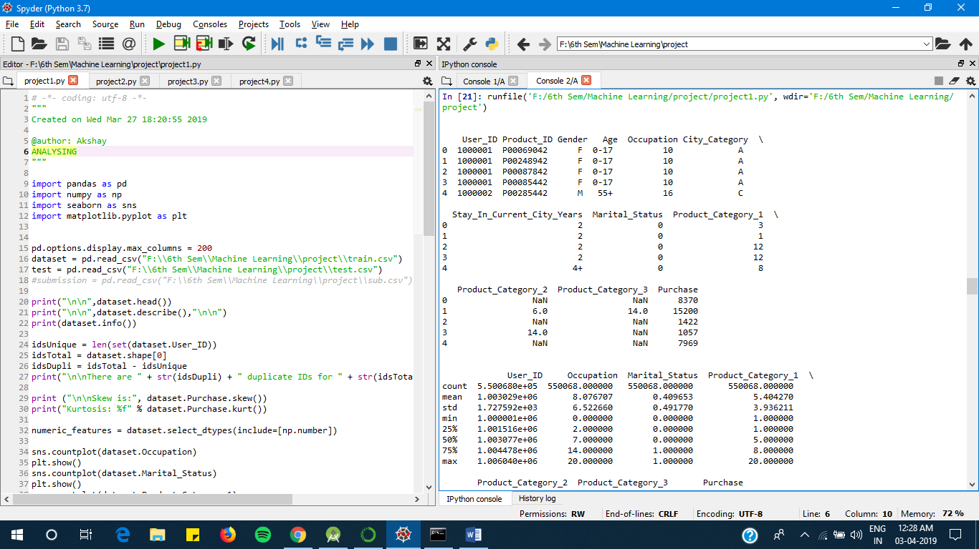

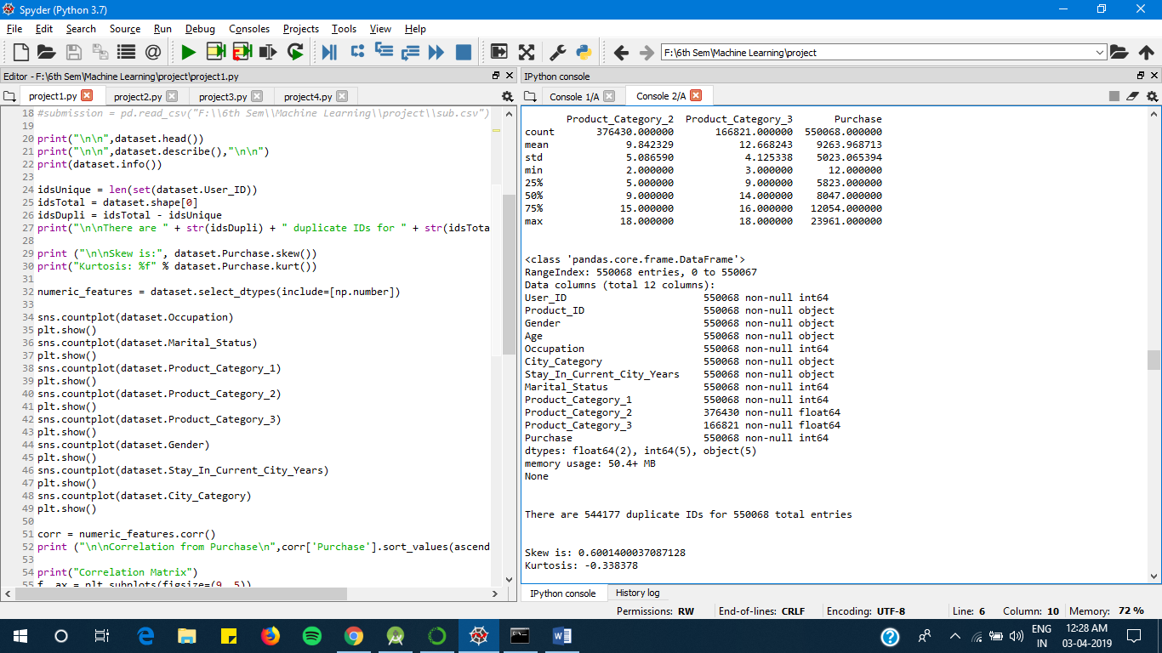

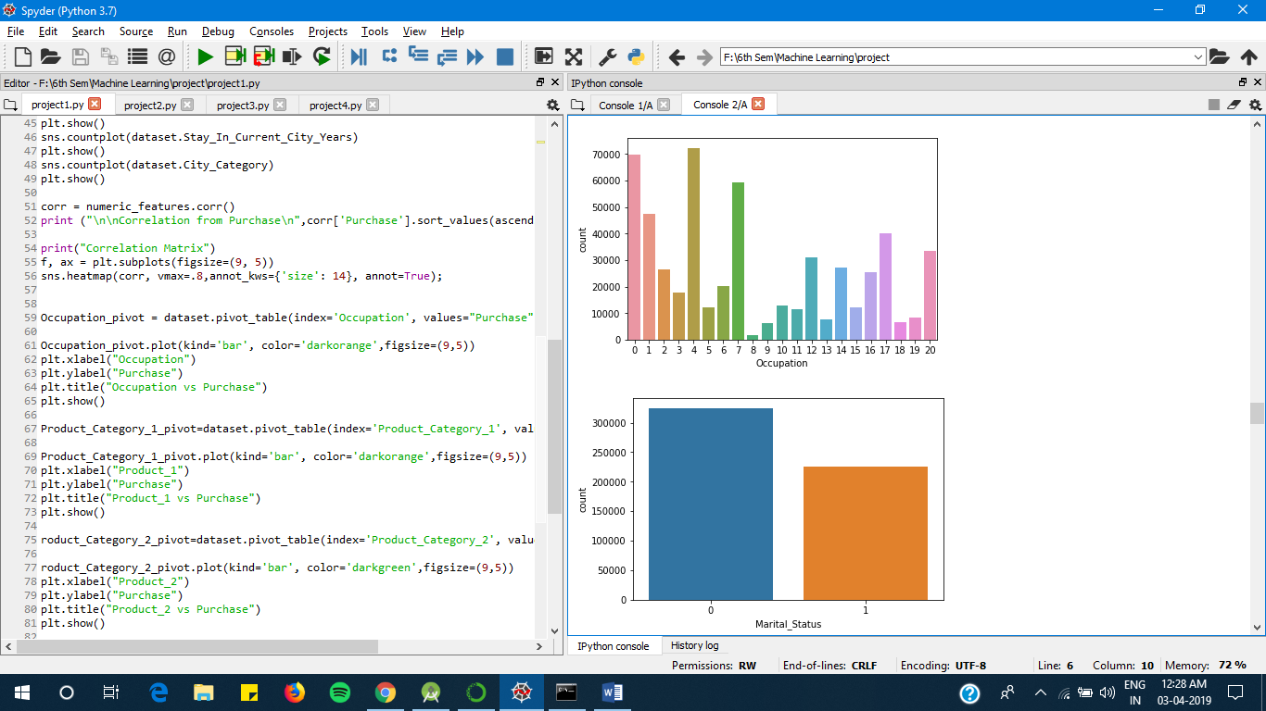

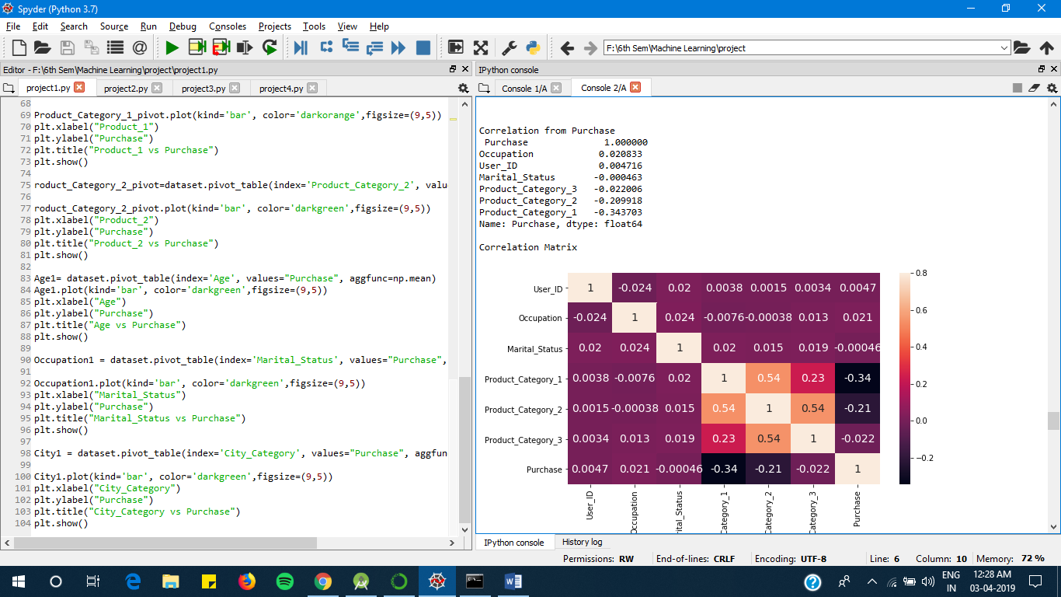

**PRE- PROCESSING**

Data pre-processing is an essential step in the process of machine learning. It includes data cleaning and data partitioning

This stage will involve removing all the NA (null) values and replacing them with some integer so that processing can be carried out. Later we can also display the unique value frequencies of all the columns and finally send this data into a modified train and test .csv files.

Because of our dataset being majority numerical in nature, we use the partitioning technique to remove the presence of unique non-numerical values and convert them to numerical.

The output obtained on pre-processing is-

This is the frequency distribution for Gender:

M 590031

F 193636

Name: Gender, dtype: int64

This is the frequency distribution for Age:

26-35 313015

36-45 156724

18-25 141953

46-50 65278

51-55 54784

55+ 30579

0-17 21334

Name: Age, dtype: int64

This is the frequency distribution for City_Category:

B 329739

C 243684

A 210244

Name: City_Category, dtype: int64

This is the frequency distribution for Stay_In_Current_City_Years:

1 276425

2 145427

3 135428

4+ 120671

0 105716

Name: Stay_In_Current_City_Years, dtype: int64

This is the frequency distribution for source:

train 550068

test 233599

Name: source, dtype: int64

Index(['F', 'M'], dtype='object')

[0 1]

1 590031

0 193636

Name: Gender, dtype: int64

Index(['0-17', '55+', '26-35', '46-50', '51-55', '36-45', '18-25'], dtype='object')

[0 1 2 3 4 5 6]

2 313015

5 156724

6 141953

3 65278

4 54784

1 30579

0 21334

Name: Age, dtype: int64

Index(['2', '4+', '3', '1', '0'], dtype='object')

[0 1 2 3 4]

3 276425

0 145427

2 135428

1 120671

4 105716

Name: Stay_In_Current_City_Years, dtype: int64

Index(['A', 'C', 'B'], dtype='object')

[0 1 2]

2 329739

1 243684

0 210244

Name: City_Category, dtype: int64

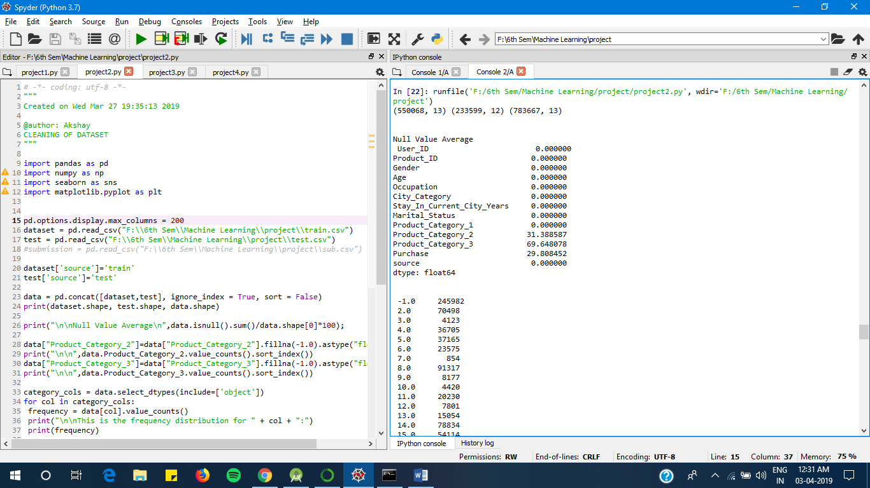

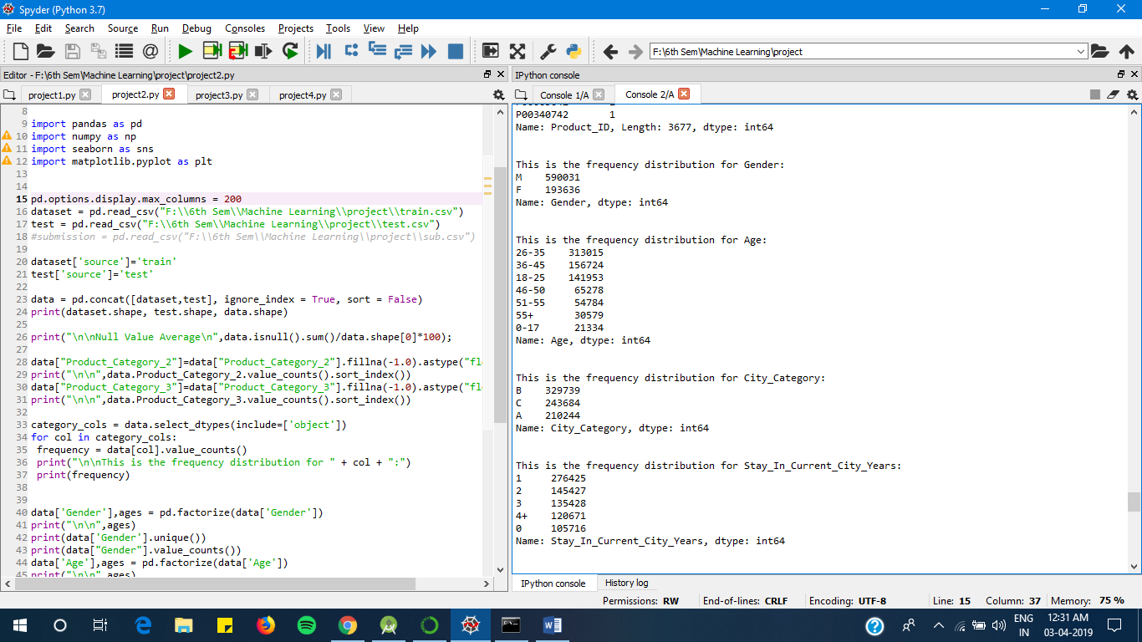

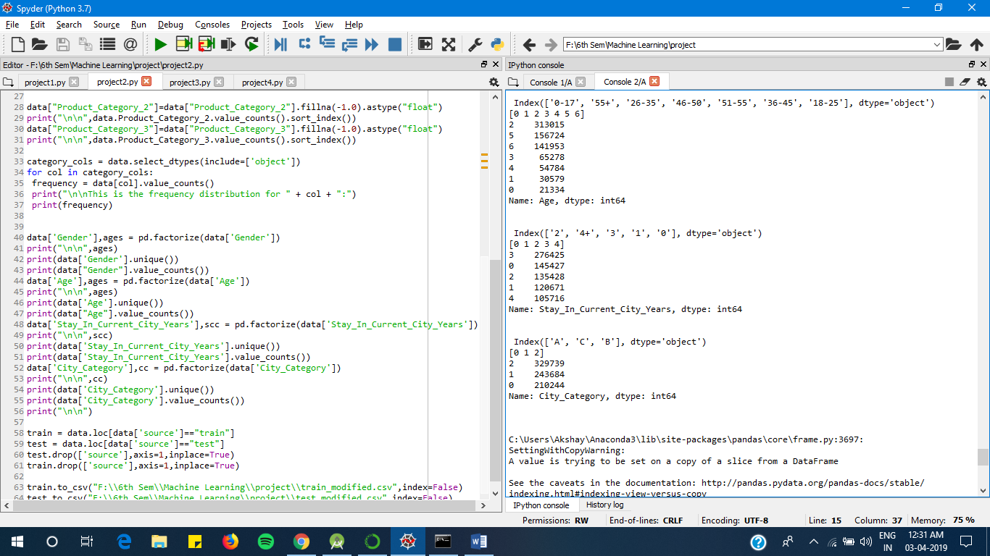

**Modified Datasets-**

**Train_modified.csv**

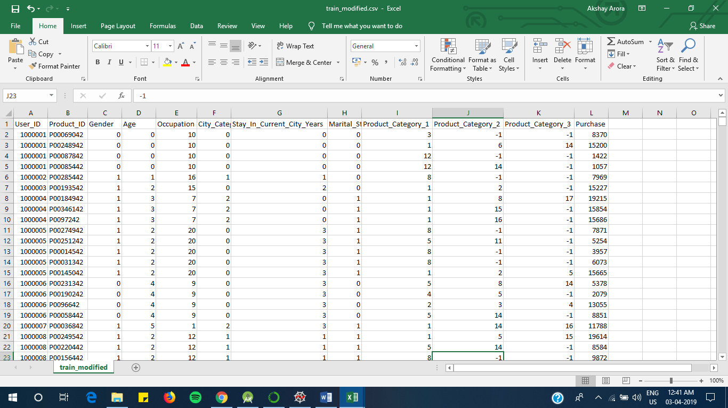

**Test_Modified.csv**

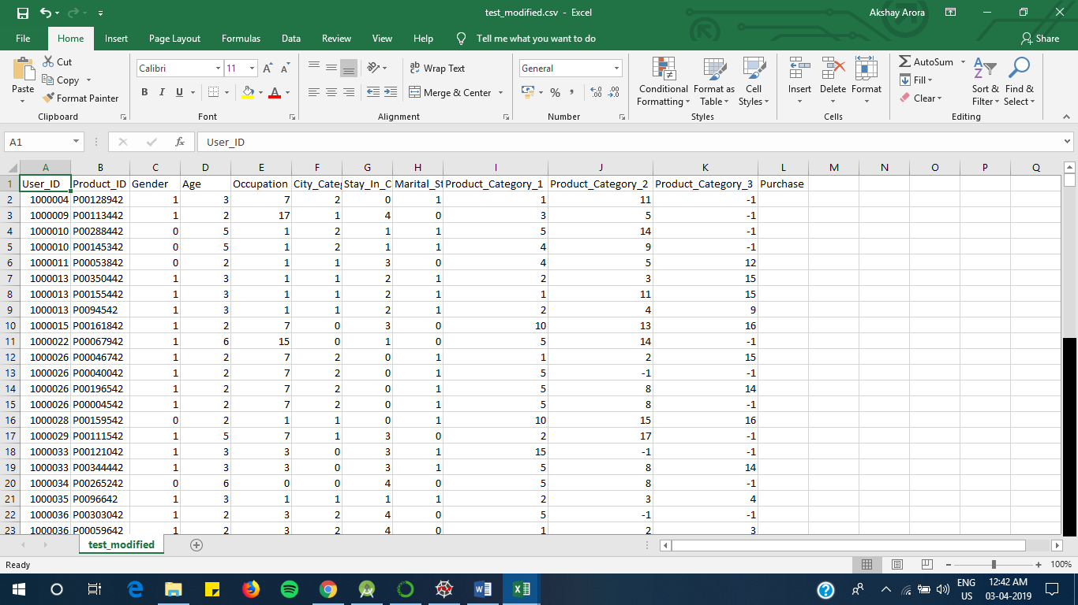

**5. Implementation**

Before selecting the models to use for the training process, we need to decide the columns/features that can be used as predictors and drop the others.

This decision needs to be made on the basis on the data analysis done at the first stage of this process.

For eg: when we made the correlation matrix of the dataset, we found that the column “purchase” was highly correlating with the column “Occupation”. This implies the column occupation should be included in the predictors.

The next step, is to use the modified train and test data and apply machine learning algorithms of various types as read about in the survey.

To predict the purchase amount using multiple regression we implemented machine learning algorithms and compared them on accuracy and performance metric. Since it is a regression problem, the loss function used is the Root Mean Squared error (RMSE).



1. **Linear Regression**

The linear regression using python's skLearn library was implemented on the transformed dataset. This was the simplest of the implementations in terms of complexity of the model.

Model Report

RMSE : 4632

CV Score : Mean - 4635 | Std - 35.02 | Min - 4545 | Max – 4688

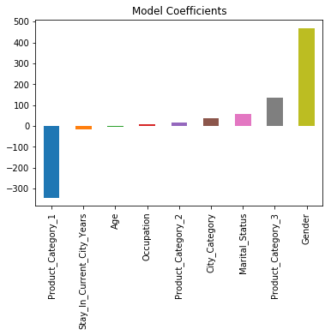 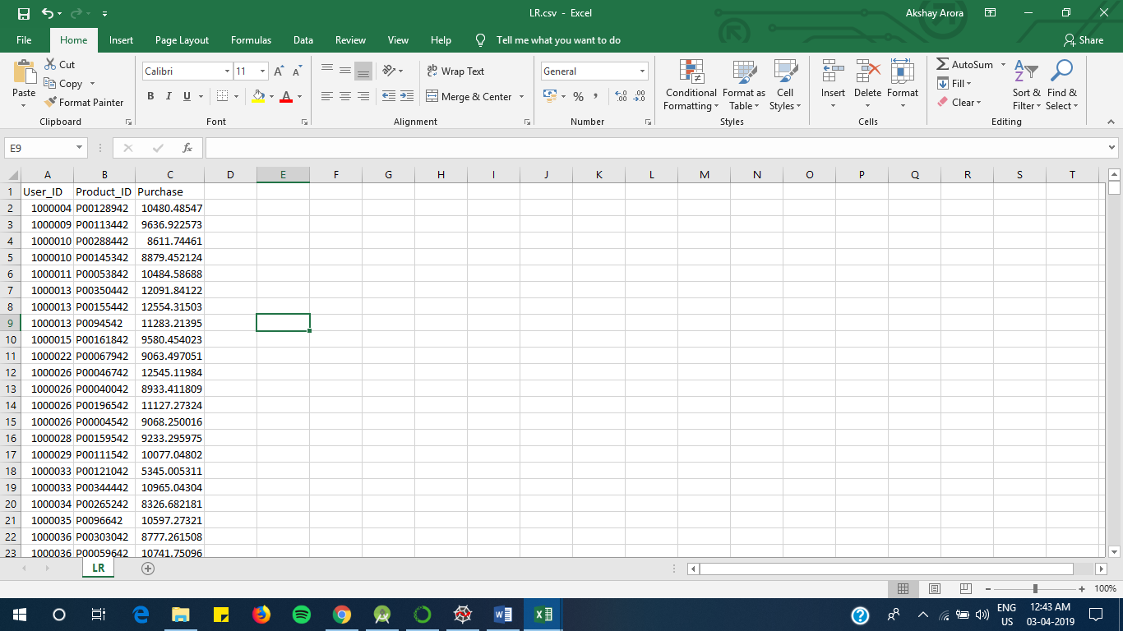

**Predicted values in LR.csv**

1. **Ridge regression**

The ridge regression using python's skLearn library was implemented on the transformed dataset.

Model Report

RMSE : 4633

CV Score : Mean - 4636 | Std - 31.86 | Min - 4570 | Max - 4687

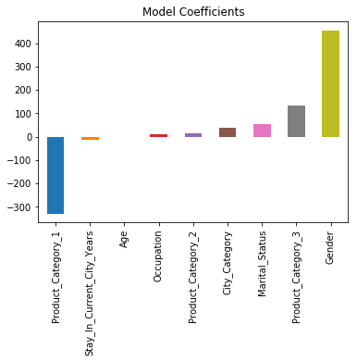 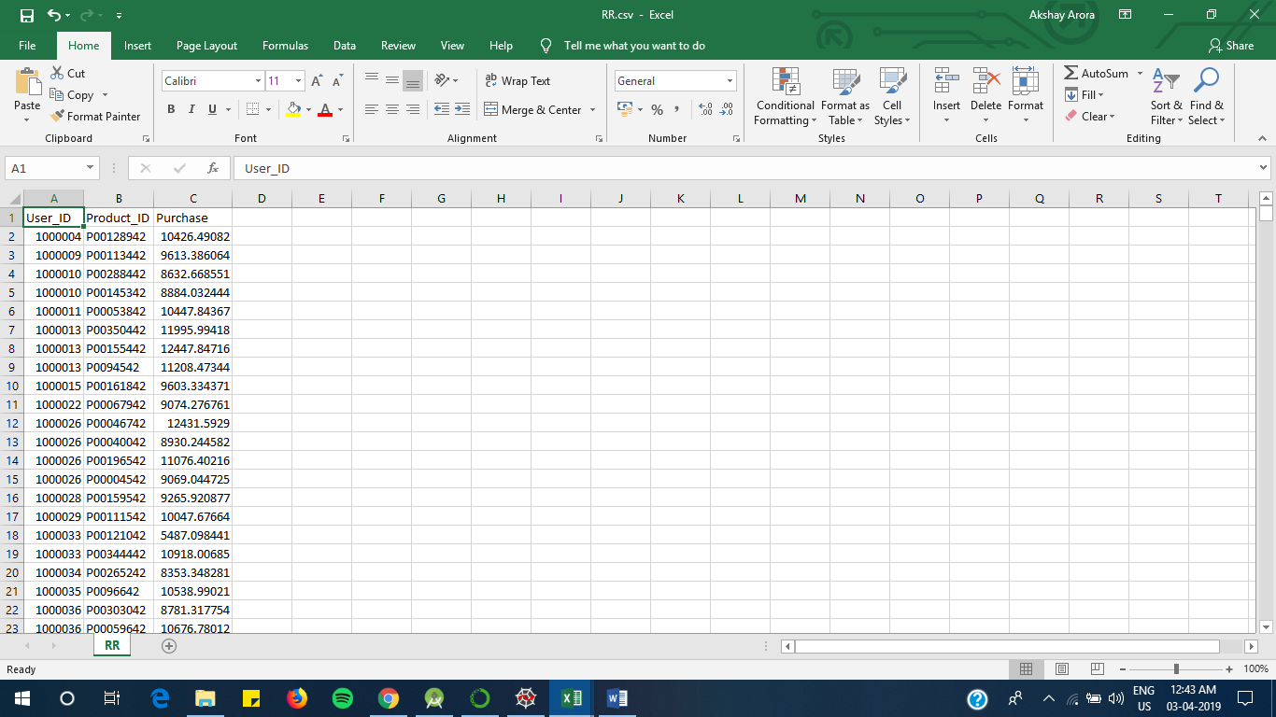

**Predicted values in RR.csv**

1. **Decision Tree Regression**

Machine learning algorithms like decision tree and regression are used for developing a simple yet efficient prediction models. Guo et al. state that a time series analysis using early purchase patters can be used to predict the future spending. The technique involved can be classified into two groups, mathematical and statistical model, and artificial intelligence model [4]. The Decision Tree technique comes under the artificial intelligence model, which develops a tree with root node containing the most important feature and subsequent nodes in the tree with less ranking features.

Model Report

RMSE : 2916

CV Score : Mean - 2947 | Std - 19.9 | Min - 2907 | Max - 2977

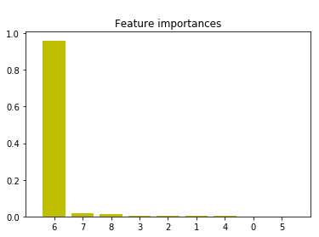Feature ranking:

x1. feature 6 (0.960362)

x2. feature 7 (0.015366)

x3. feature 8 (0.010731)

x4. feature 3 (0.004482)

x5. feature 2 (0.003268)

x6. feature 1 (0.002386)

x7. feature 4 (0.001721)

x8. feature 0 (0.000868)

x9. feature 5 (0.000815)

**Predicted values in DT.csv**

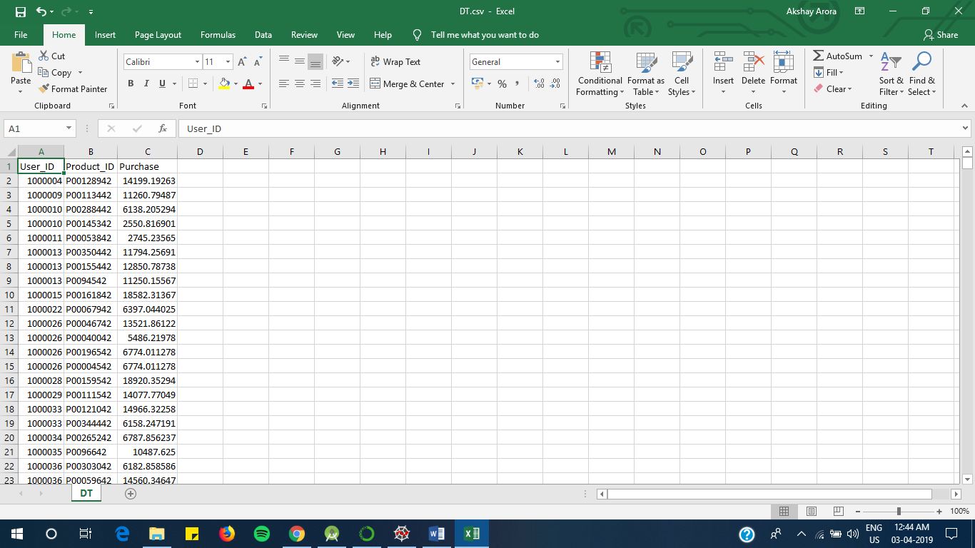

1. **XGB Regression**

The XGBoost model internally implements the stepwise, ridge regression which dynamically selects the features and removes the multi-collinearity with the features. This implementation gave the bet results of this dataset. It uses ensemble model to learn from the weak predictors and eliminate the less important features to develop a strong model.

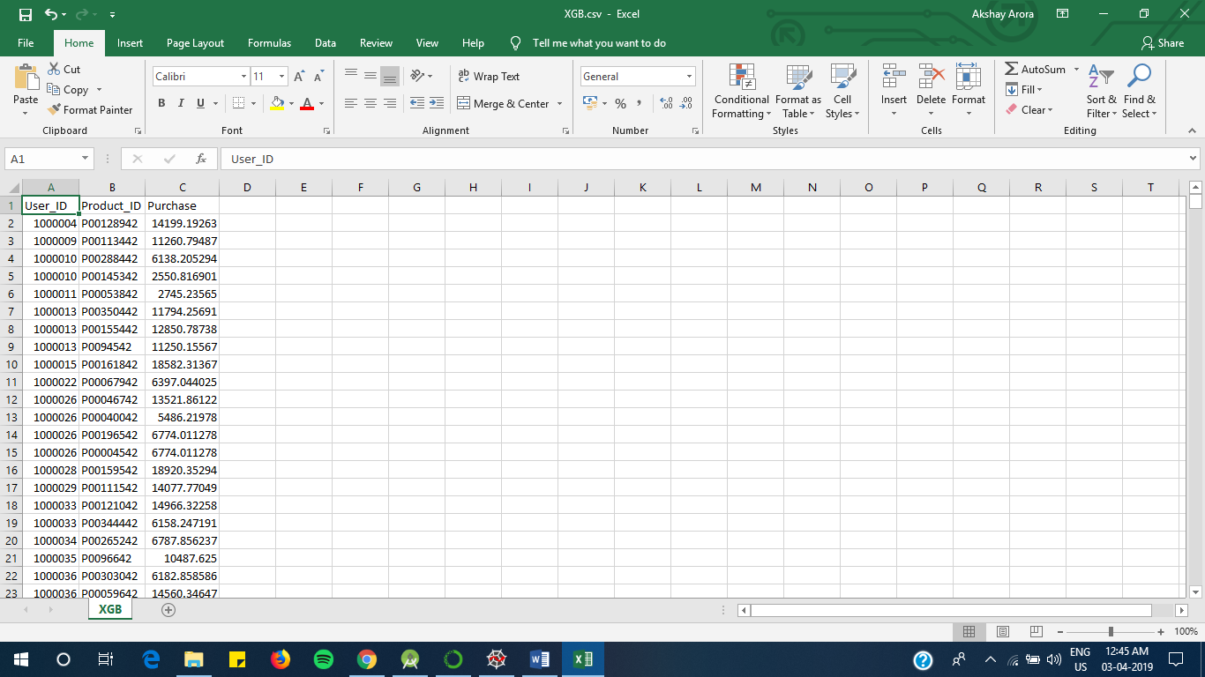Mean Absolute Error : 392.22502938349544

RMSE : 2950

Feature order:

1. feature 6 (0.886407)

2. feature 3 (0.032552)

3. feature 8 (0.028489)

4. feature 7 (0.025543)

5. feature 2 (0.007178)

6. feature 1 (0.005710)

7. feature 4 (0.004938)

8. feature 0 (0.004783)

9. feature 5 (0.004399)

**Predicted values in XGB.csv**

1. **Random forest regression**

Model Report

RMSE : 3754

CV Score : Mean - 3714 | Std - 22.85 | Min - 3672 | Max - 3750

Mean Absolute Error : 3.7333049827565437

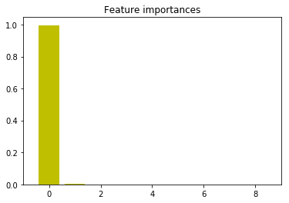RMSE : 3754

Feature order:

1. feature 6 (0.996204)

2. feature 8 (0.001988)

3. feature 7 (0.001205)

4. feature 3 (0.000603)

5. feature 5 (0.000000)

6. feature 4 (0.000000)

7. feature 2 (0.000000)

8. feature 1 (0.000000)

9. feature 0 (0.000000)

**Predicted values in RF.csv**

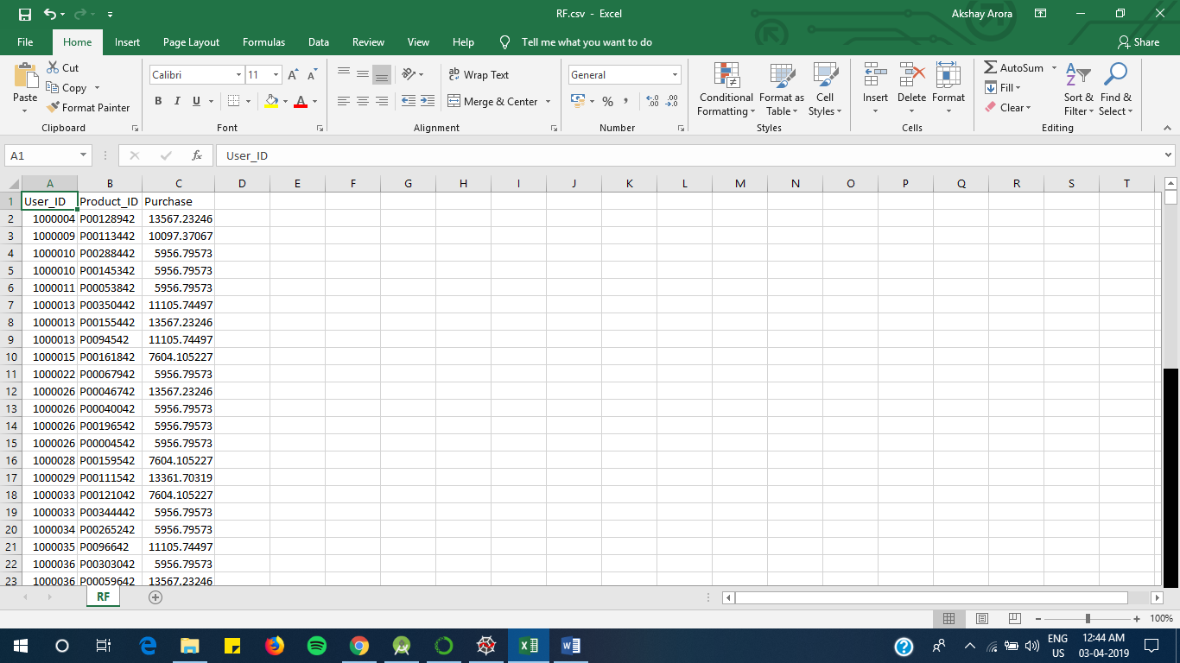

**OUTPUTS-**

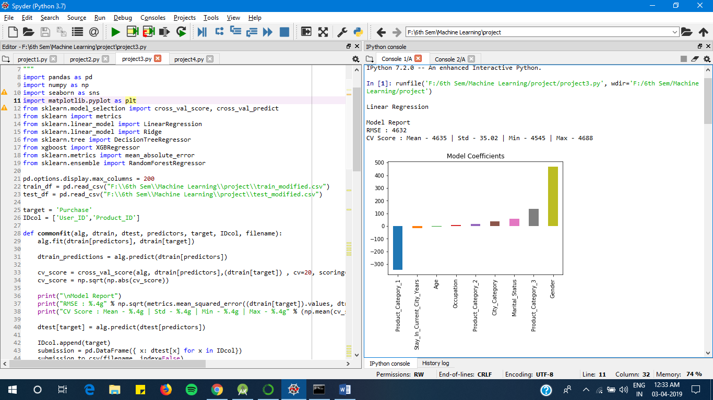

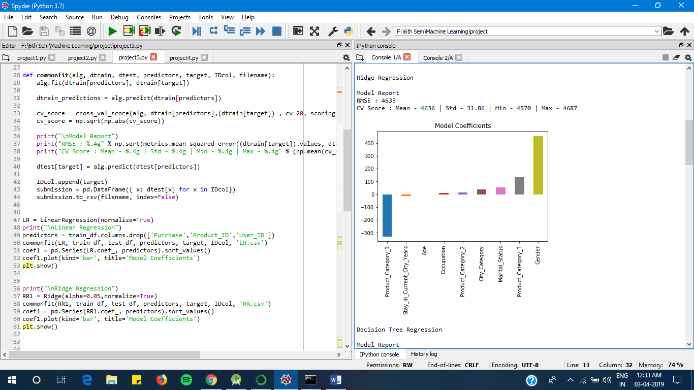

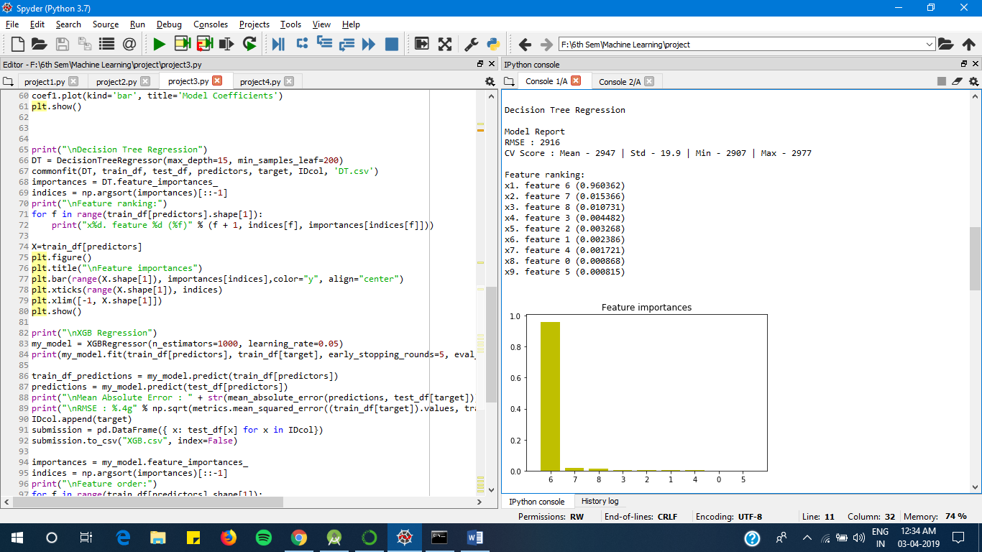

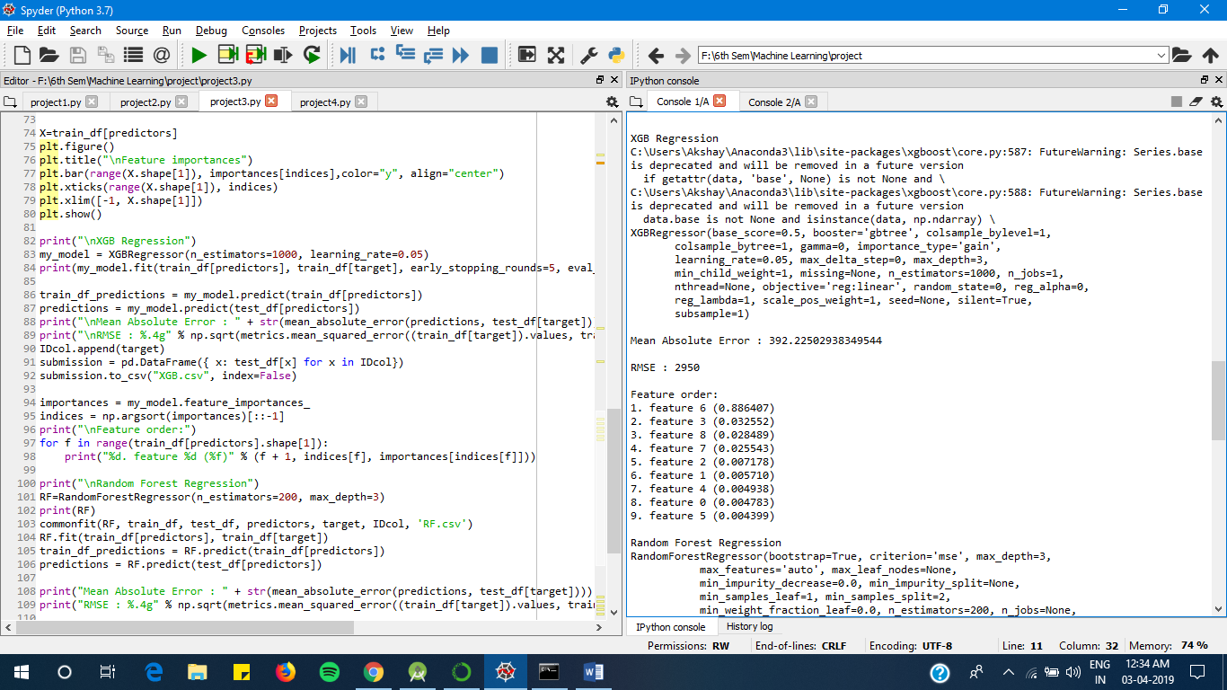

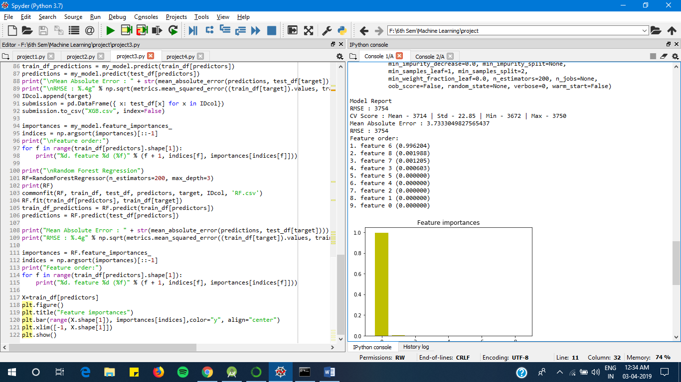

1. **Rule Based Learning**

Product_Category_1 <= 2.5, Product_Category_1 <= 1.5, Occupation <= 18.5, Product_Category_2 <= 16.5, Product_Category_3 <= 16.5, Product_Category_3 <= 8.5, Occupation <= 6.5, Occupation <= 3.5, Occupation <= 2.5, City_Category <= 0.5, Product_Category_3 <= 6.5, Occupation <= 0.5, Product_Category_2 <= 4.0

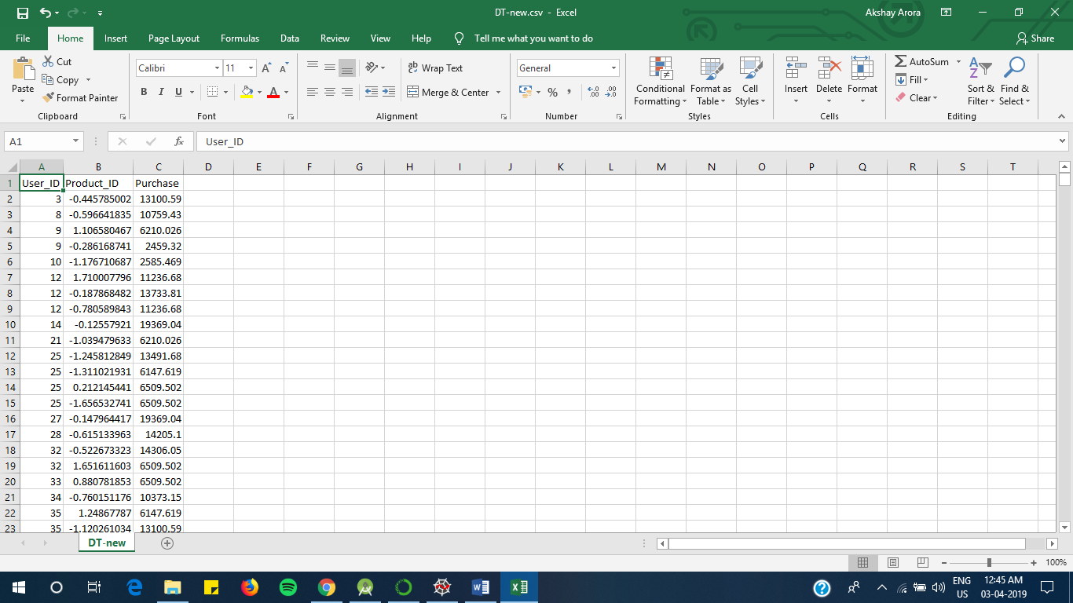Before Rule Based:

Model Report

RMSE : 2996

CV Score : Mean - 3242 | Std - 54.63 | Min - 3031 | Max - 3289

After Rule Based:

Model Report

RMSE : 2291

CV Score : Mean - 3300 | Std - 28.11 | Min - 3249 | Max – 3350

**Predicted values in DT-new.csv**

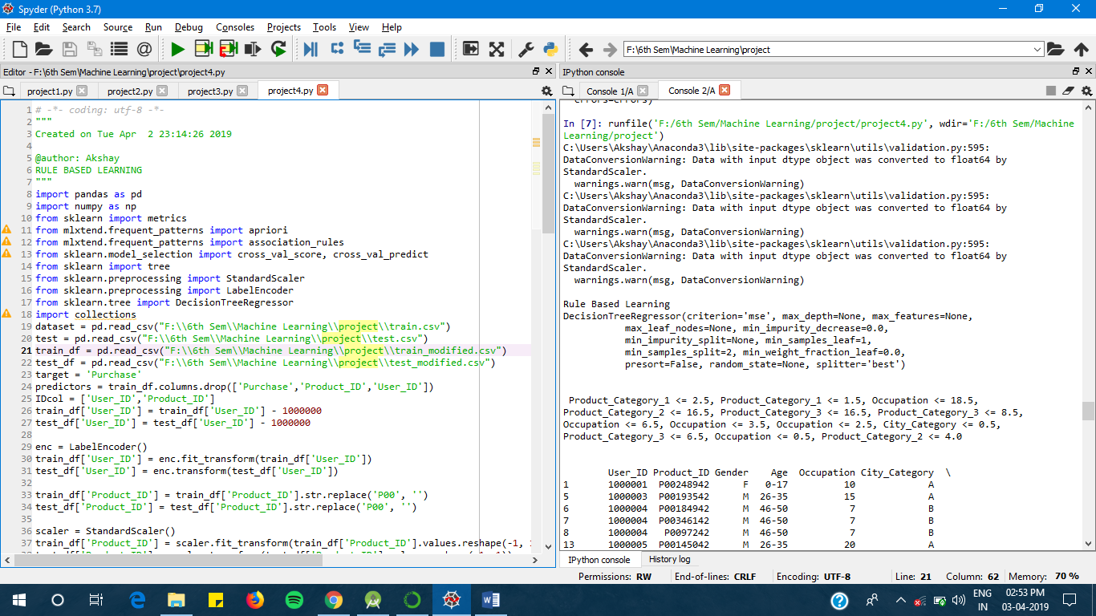

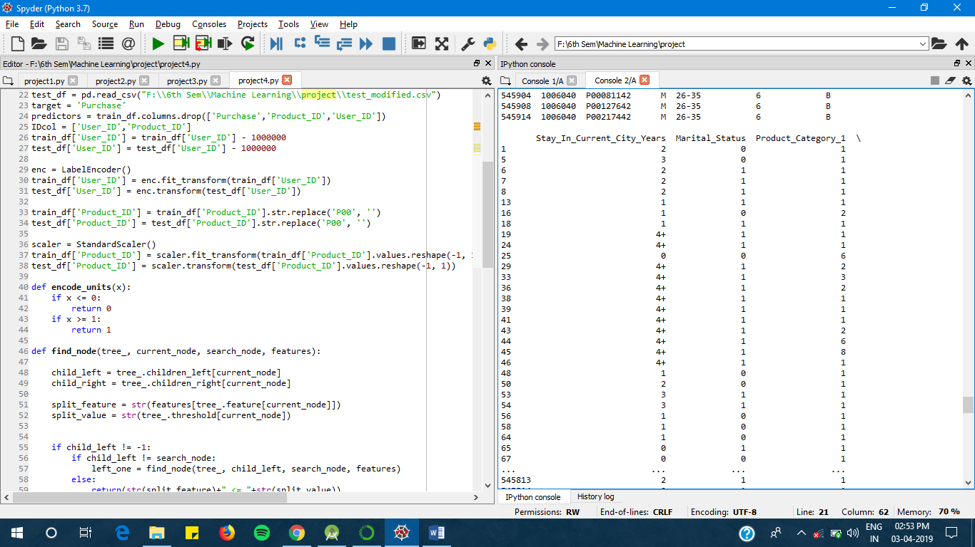

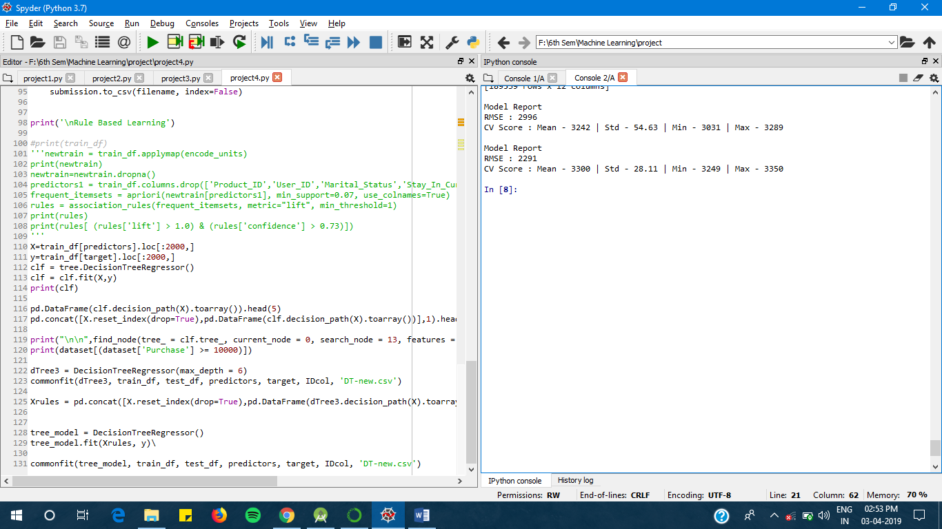

**RESULT**

The below figure depicts the plot of RMSE for all the above implementation for visual comparison.

Lower the value of RMSE better the prediction by the algorithm.

According to the obtained RMSE value Rule based decision tree is the most optimized algorithm to analyse the black Friday sales

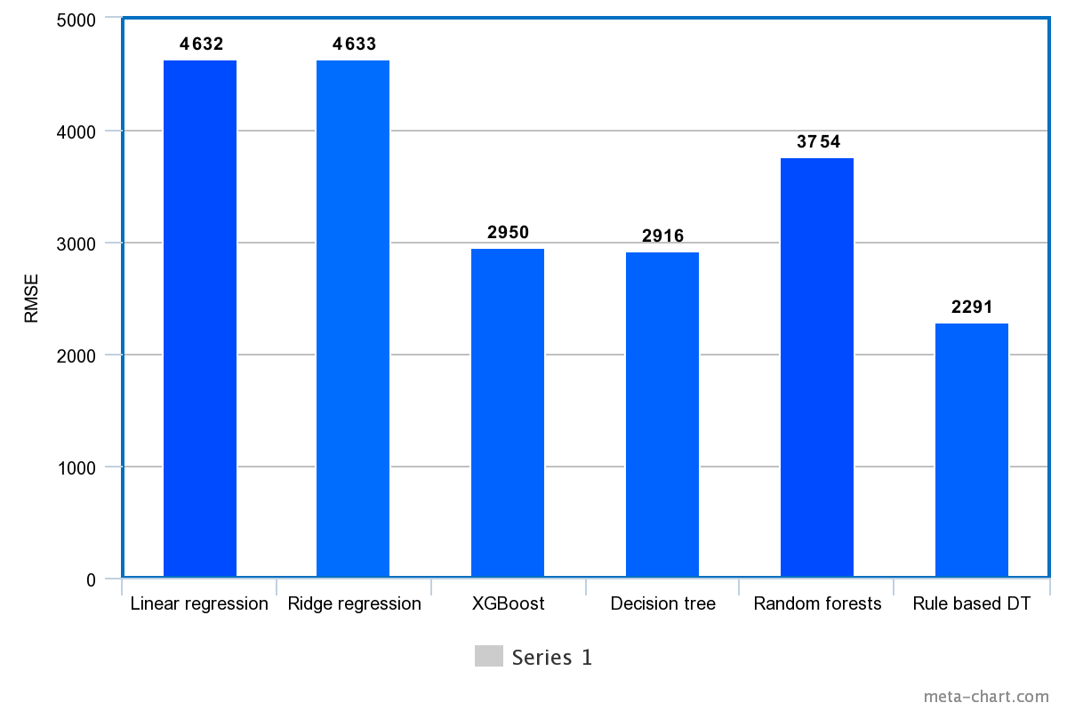

**CONCLUSION**

We conclude that the complex models like neural network are an overkill for simple problems like regression. And simpler models along with proper data cleaning perform well for the regression.

Also, based on the current trend, the number of shoppers on the Black Friday is only going to increase. We conclude that machine learning techniques produce better prediction models that can be used at stores and the store owners can analyse their customer base to better target the customers and increase the sales on a Black Friday.

It also shows that the data must be pre-processed to attain an effective dataset for developing the prediction model. Several techniques were used to attain the best model. However, there is still no definite solution as to what the correct technique is to attain a model with high accuracy. Rule based decision tree can be used though.

To improve the results, a dataset with sufficient features and increase in quantity must be obtained. Further research must be conducted in enhancing the existing machine learning techniques to work in real time and develop an efficient model. Also, the models developed must be tested on data.

**REFERENCES**

[1] M. Petrescu and M. Murphy, "Black Friday and Cyber Monday: a case study" in International Journal of Electronic Marketing and Retailing (IJEMR), voL 5, no.3, 2013.

[2] L. P. Barroso, W. O. Bussab, and M. Knott, "Best linear unbiased predictor in the mixed model with incomplete data," Communications in Statistics Theory and Methods, vol. 27, no. 1, pp . 121-129, 1998. doi: 10.108010361092980883265 4J.

[3] I. Guyon and A. Elisseeff, "An introduction to variable and feature selection," J. Mach. Learn. Res., vol. 3, pp. 1157-1182, Mar. 2003.

[4] Z. X. Guo, W. K. Wong , and M. Li, "A multivariate intelligent decision-making model for retail sales forecasting," Decision Support Syst., voL 55, pp -247-255, Apr. 2013 .

[5] A. Soroush , A. Bahreininejad, and 1. van den Berg , "A hybrid customer prediction system based on multiple forward stepwise logistic regression mode ," Intell . Data Anal. , vol. 16, pp. 265-278, Mar. 2012.

[6] L. Bing and S. Yuliang, "Prediction ofuser 's purchase intention based on machine learning," 3rd International Conference on Soft Computing Machine Intelligence (ISCMI)., pp.99·103, Nov. 2016 .

[7] Y. Qin and H. Li, "Sales forecast based on BP neural network", 2011 IEEE 3rd International Conference on Communication Software and Network., pp. 186-189, May 2011

[8] K. Singh and R. Wajgi, "Data analysis and visualization of sales data," 2016 World Conference on Futuristic Trends in Research and Innovation for Social Welfare (Startup Conclave), Coimbatore, pp. 1-6, Mar. 2016 .

[9] https j/datahack.analyticsvidhya.com/contest!black·friday/#data_dictionary

[10] https .zIwww .analyticsvidhya.comlblog/2015108/comprehensive-guide-re gression!

[11] https j Imachinelearningmastery.comlregression-tutorial-keras-deep-Ieam i ng-library-python!

[12] http ://scikit-Ieam.org/stable/auto_examplesilinear_modellplot_ols.html

**APPENDIX (SAMPLE CODE)**

**ANALYSING**

# -*- coding: utf-8 -*-

"""

Created on Wed Mar 27 18:20:55 2019

@author: Akshay

ANALYSING

"""

import pandas as pd

import numpy as np

import seaborn as sns

import matplotlib.pyplot as plt

pd.options.display.max_columns = 200

dataset = pd.read_csv("F:\\6th Sem\\Machine Learning\\project\\train.csv")

test = pd.read_csv("F:\\6th Sem\\Machine Learning\\project\\test.csv")

#submission = pd.read_csv("F:\\6th Sem\\Machine Learning\\project\\sub.csv")

print("\n\n",dataset.head())

print("\n\n",dataset.describe(),"\n\n")

print(dataset.info())

idsUnique = len(set(dataset.User_ID))

idsTotal = dataset.shape[0]

idsDupli = idsTotal - idsUnique

print("\n\nThere are " + str(idsDupli) + " duplicate IDs for " + str(idsTotal) + " total entries")

print ("\n\nSkew is:", dataset.Purchase.skew())

print("Kurtosis: %f" % dataset.Purchase.kurt())

numeric_features = dataset.select_dtypes(include=[np.number])

sns.countplot(dataset.Occupation)

plt.show()

sns.countplot(dataset.Marital_Status)

plt.show()

sns.countplot(dataset.Product_Category_1)

plt.show()

sns.countplot(dataset.Product_Category_2)

plt.show()

sns.countplot(dataset.Product_Category_3)

plt.show()

sns.countplot(dataset.Gender)

plt.show()

sns.countplot(dataset.Stay_In_Current_City_Years)

plt.show()

sns.countplot(dataset.City_Category)

plt.show()

corr = numeric_features.corr()

print ("\n\nCorrelation from Purchase\n",corr['Purchase'].sort_values(ascending=False),"\n")

print("Correlation Matrix")

f, ax = plt.subplots(figsize=(9, 5))

sns.heatmap(corr, vmax=.8,annot_kws={'size': 14}, annot=True);

Occupation_pivot = dataset.pivot_table(index='Occupation', values="Purchase", aggfunc=np.mean)

Occupation_pivot.plot(kind='bar', color='darkorange',figsize=(9,5))

plt.xlabel("Occupation")

plt.ylabel("Purchase")

plt.title("Occupation vs Purchase")

plt.show()

Product_Category_1_pivot=dataset.pivot_table(index='Product_Category_1', values="Purchase", aggfunc=np.mean)

Product_Category_1_pivot.plot(kind='bar', color='darkorange',figsize=(9,5))

plt.xlabel("Product_1")

plt.ylabel("Purchase")

plt.title("Product_1 vs Purchase")

plt.show()

roduct_Category_2_pivot=dataset.pivot_table(index='Product_Category_2', values="Purchase")

roduct_Category_2_pivot.plot(kind='bar', color='darkgreen',figsize=(9,5))

plt.xlabel("Product_2")

plt.ylabel("Purchase")

plt.title("Product_2 vs Purchase")

plt.show()

Age1= dataset.pivot_table(index='Age', values="Purchase", aggfunc=np.mean)

Age1.plot(kind='bar', color='darkgreen',figsize=(9,5))

plt.xlabel("Age")

plt.ylabel("Purchase")

plt.title("Age vs Purchase")

plt.show()

Occupation1 = dataset.pivot_table(index='Marital_Status', values="Purchase", aggfunc=np.mean)

Occupation1.plot(kind='bar', color='darkgreen',figsize=(9,5))

plt.xlabel("Marital_Status")

plt.ylabel("Purchase")

plt.title("Marital_Status vs Purchase")

plt.show()

City1 = dataset.pivot_table(index='City_Category', values="Purchase", aggfunc=np.mean)

City1.plot(kind='bar', color='darkgreen',figsize=(9,5))

plt.xlabel("City_Category")

plt.ylabel("Purchase")

plt.title("City_Category vs Purchase")

plt.show()

**PRE-PROCESSING**

# -*- coding: utf-8 -*-

"""

Created on Wed Mar 27 19:35:13 2019

@author: Akshay

CLEANING OF DATASET

"""

import pandas as pd

import numpy as np

import seaborn as sns

import matplotlib.pyplot as plt

pd.options.display.max_columns = 200

dataset = pd.read_csv("F:\\6th Sem\\Machine Learning\\project\\train.csv")

test = pd.read_csv("F:\\6th Sem\\Machine Learning\\project\\test.csv")

#submission = pd.read_csv("F:\\6th Sem\\Machine Learning\\project\\sub.csv")

dataset['source']='train'

test['source']='test'

data = pd.concat([dataset,test], ignore_index = True, sort = False)

print(dataset.shape, test.shape, data.shape)

print("\n\nNull Value Average\n",data.isnull().sum()/data.shape[0]*100);

data["Product_Category_2"]=data["Product_Category_2"].fillna(-1.0).astype("float")

print("\n\n",data.Product_Category_2.value_counts().sort_index())

data["Product_Category_3"]=data["Product_Category_3"].fillna(-1.0).astype("float")

print("\n\n",data.Product_Category_3.value_counts().sort_index())

category_cols = data.select_dtypes(include=['object'])

for col in category_cols:

frequency = data[col].value_counts()

print("\n\nThis is the frequency distribution for " + col + ":")

print(frequency)

data['Gender'],ages = pd.factorize(data['Gender'])

print("\n\n",ages)

print(data['Gender'].unique())

print(data["Gender"].value_counts())

data['Age'],ages = pd.factorize(data['Age'])

print("\n\n",ages)

print(data['Age'].unique())

print(data["Age"].value_counts())

data['Stay_In_Current_City_Years'],scc = pd.factorize(data['Stay_In_Current_City_Years'])

print("\n\n",scc)

print(data['Stay_In_Current_City_Years'].unique())

print(data['Stay_In_Current_City_Years'].value_counts())

data['City_Category'],cc = pd.factorize(data['City_Category'])

print("\n\n",cc)

print(data['City_Category'].unique())

print(data['City_Category'].value_counts())

print("\n\n")

train = data.loc[data['source']=="train"]

test = data.loc[data['source']=="test"]

test.drop(['source'],axis=1,inplace=True)

train.drop(['source'],axis=1,inplace=True)

train.to_csv("F:\\6th Sem\\Machine Learning\\project\\train_modified.csv",index=False)

test.to_csv("F:\\6th Sem\\Machine Learning\\project\\test_modified.csv",index=False)

**PREDICTING**

# -*- coding: utf-8 -*-

"""

Created on Wed Mar 27 21:20:26 2019

@author: Akshay

PREDICTING

"""

import pandas as pd

import numpy as np

import seaborn as sns

import matplotlib.pyplot as plt

from sklearn.model_selection import cross_val_score, cross_val_predict

from sklearn import metrics

from sklearn.linear_model import LinearRegression

from sklearn.linear_model import Ridge

from sklearn.tree import DecisionTreeRegressor

from xgboost import XGBRegressor

from sklearn.metrics import mean_absolute_error

from sklearn.ensemble import RandomForestRegressor

pd.options.display.max_columns = 200

train_df = pd.read_csv("F:\\6th Sem\\Machine Learning\\project\\train_modified.csv")

test_df = pd.read_csv("F:\\6th Sem\\Machine Learning\\project\\test_modified.csv")

target = 'Purchase'

IDcol = ['User_ID','Product_ID']

def commonfit(alg, dtrain, dtest, predictors, target, IDcol, filename):

alg.fit(dtrain[predictors], dtrain[target])

dtrain_predictions = alg.predict(dtrain[predictors])

cv_score = cross_val_score(alg, dtrain[predictors],(dtrain[target]) , cv=20, scoring='neg_mean_squared_error')

cv_score = np.sqrt(np.abs(cv_score))

print("\nModel Report")

print("RMSE : %.4g" % np.sqrt(metrics.mean_squared_error((dtrain[target]).values, dtrain_predictions)))

print("CV Score : Mean - %.4g | Std - %.4g | Min - %.4g | Max - %.4g" % (np.mean(cv_score),np.std(cv_score),np.min(cv_score),np.max(cv_score)))

dtest[target] = alg.predict(dtest[predictors])

IDcol.append(target)

submission = pd.DataFrame({ x: dtest[x] for x in IDcol})

submission.to_csv(filename, index=False)

LR = LinearRegression(normalize=True)

print("\nLinear Regression")

predictors = train_df.columns.drop(['Purchase','Product_ID','User_ID'])

commonfit(LR, train_df, test_df, predictors, target, IDcol, 'LR.csv')

coef1 = pd.Series(LR.coef_, predictors).sort_values()

coef1.plot(kind='bar', title='Model Coefficients')

plt.show()

print("\nRidge Regression")

RR1 = Ridge(alpha=0.05,normalize=True)

commonfit(RR1, train_df, test_df, predictors, target, IDcol, 'RR.csv')

coef1 = pd.Series(RR1.coef_, predictors).sort_values()

coef1.plot(kind='bar', title='Model Coefficients')

plt.show()

print("\nDecision Tree Regression")

DT = DecisionTreeRegressor(max_depth=15, min_samples_leaf=200)

commonfit(DT, train_df, test_df, predictors, target, IDcol, 'DT.csv')

importances = DT.feature_importances_

indices = np.argsort(importances)[::-1]

print("\nFeature ranking:")

for f in range(train_df[predictors].shape[1]):

print("x%d. feature %d (%f)" % (f + 1, indices[f], importances[indices[f]]))

X=train_df[predictors]

plt.figure()

plt.title("\nFeature importances")

plt.bar(range(X.shape[1]), importances[indices],color="y", align="center")

plt.xticks(range(X.shape[1]), indices)

plt.xlim([-1, X.shape[1]])

plt.show()

print("\nXGB Regression")

my_model = XGBRegressor(n_estimators=1000, learning_rate=0.05)

print(my_model.fit(train_df[predictors], train_df[target], early_stopping_rounds=5, eval_set=[(test_df[predictors], test_df[target])], verbose=False))

train_df_predictions = my_model.predict(train_df[predictors])

predictions = my_model.predict(test_df[predictors])

print("\nMean Absolute Error : " + str(mean_absolute_error(predictions, test_df[target])))

print("\nRMSE : %.4g" % np.sqrt(metrics.mean_squared_error((train_df[target]).values, train_df_predictions)))

IDcol.append(target)

submission = pd.DataFrame({ x: test_df[x] for x in IDcol})

submission.to_csv("XGB.csv", index=False)

importances = my_model.feature_importances_

indices = np.argsort(importances)[::-1]

print("\nFeature order:")

for f in range(train_df[predictors].shape[1]):

print("%d. feature %d (%f)" % (f + 1, indices[f], importances[indices[f]]))

print("\nRandom Forest Regression")

RF=RandomForestRegressor(n_estimators=200, max_depth=3)

print(RF)

commonfit(RF, train_df, test_df, predictors, target, IDcol, 'RF.csv')

RF.fit(train_df[predictors], train_df[target])

train_df_predictions = RF.predict(train_df[predictors])

predictions = RF.predict(test_df[predictors])

print("Mean Absolute Error : " + str(mean_absolute_error(predictions, test_df[target])))

print("RMSE : %.4g" % np.sqrt(metrics.mean_squared_error((train_df[target]).values, train_df_predictions)))

importances = RF.feature_importances_

indices = np.argsort(importances)[::-1]

print("Feature order:")

for f in range(train_df[predictors].shape[1]):

print("%d. feature %d (%f)" % (f + 1, indices[f], importances[indices[f]]))

X=train_df[predictors]

plt.figure()

plt.title("Feature importances")

plt.bar(range(X.shape[1]), importances[indices],color="y", align="center")

plt.xlim([-1, X.shape[1]])

plt.show()

**RULE BASED LEARNING**  
# -*- coding: utf-8 -*-

"""

Created on Tue Apr 2 23:14:26 2019

@author: Akshay

RULE BASED LEARNING

"""

import pandas as pd

import numpy as np

from sklearn import metrics

from mlxtend.frequent_patterns import apriori

from mlxtend.frequent_patterns import association_rules

from sklearn.model_selection import cross_val_score, cross_val_predict

from sklearn import tree

from sklearn.preprocessing import StandardScaler

from sklearn.preprocessing import LabelEncoder

from sklearn.tree import DecisionTreeRegressor

import collections

dataset = pd.read_csv("F:\\6th Sem\\Machine Learning\\project\\train.csv")

test = pd.read_csv("F:\\6th Sem\\Machine Learning\\project\\test.csv")

train_df = pd.read_csv("F:\\6th Sem\\Machine Learning\\project\\train_modified.csv")

test_df = pd.read_csv("F:\\6th Sem\\Machine Learning\\project\\test_modified.csv")

target = 'Purchase'

predictors = train_df.columns.drop(['Purchase','Product_ID','User_ID'])

IDcol = ['User_ID','Product_ID']

train_df['User_ID'] = train_df['User_ID'] - 1000000

test_df['User_ID'] = test_df['User_ID'] - 1000000

enc = LabelEncoder()

train_df['User_ID'] = enc.fit_transform(train_df['User_ID'])

test_df['User_ID'] = enc.transform(test_df['User_ID'])

train_df['Product_ID'] = train_df['Product_ID'].str.replace('P00', '')

test_df['Product_ID'] = test_df['Product_ID'].str.replace('P00', '')

scaler = StandardScaler()

train_df['Product_ID'] = scaler.fit_transform(train_df['Product_ID'].values.reshape(-1, 1))

test_df['Product_ID'] = scaler.transform(test_df['Product_ID'].values.reshape(-1, 1))

def encode_units(x):

if x <= 0:

return 0

if x >= 1:

return 1

def find_node(tree_, current_node, search_node, features):

child_left = tree_.children_left[current_node]

child_right = tree_.children_right[current_node]

split_feature = str(features[tree_.feature[current_node]])

split_value = str(tree_.threshold[current_node])

if child_left != -1:

if child_left != search_node:

left_one = find_node(tree_, child_left, search_node, features)

else:

return(str(split_feature)+" <= "+str(split_value))

else:

return ""

if child_right != -1:

if child_right != search_node:

right_one = find_node(tree_, child_right, search_node, features)

else:

return(str(split_feature)+" > "+str(split_value))

else:

return ""

if len(left_one)>0:

return(str(split_feature)+" <= "+str(split_value)+", "+left_one)

elif len(right_one)>0:

return(str(split_feature)+" > "+str(split_value)+","+right_one)

else:

return ""

def commonfit(alg, dtrain, dtest, predictors, target, IDcol, filename):

alg.fit(dtrain[predictors], dtrain[target])

dtrain_predictions = alg.predict(dtrain[predictors])

cv_score = cross_val_score(alg, dtrain[predictors],(dtrain[target]) , cv=20, scoring='neg_mean_squared_error')

cv_score = np.sqrt(np.abs(cv_score))

print("\nModel Report")

print("RMSE : %.4g" % np.sqrt(metrics.mean_squared_error((dtrain[target]).values, dtrain_predictions)))

print("CV Score : Mean - %.4g | Std - %.4g | Min - %.4g | Max - %.4g" % (np.mean(cv_score),np.std(cv_score),np.min(cv_score),np.max(cv_score)))

dtest[target] = alg.predict(dtest[predictors])

IDcol.append(target)

submission = pd.DataFrame({ x: dtest[x] for x in IDcol})

submission.to_csv(filename, index=False)

print('\nRule Based Learning')

#print(train_df)

'''newtrain = train_df.applymap(encode_units)

print(newtrain)

newtrain=newtrain.dropna()

predictors1 = train_df.columns.drop(['Product_ID','User_ID','Marital_Status','Stay_In_Current_City_Years'])

frequent_itemsets = apriori(newtrain[predictors1], min_support=0.07, use_colnames=True)

rules = association_rules(frequent_itemsets, metric="lift", min_threshold=1)

print(rules)

print(rules[ (rules['lift'] > 1.0) & (rules['confidence'] > 0.73)])

'''

X=train_df[predictors].loc[:2000,]

y=train_df[target].loc[:2000,]

clf = tree.DecisionTreeRegressor()

clf = clf.fit(X,y)

print(clf)

pd.DataFrame(clf.decision_path(X).toarray()).head(5)

pd.concat([X.reset_index(drop=True),pd.DataFrame(clf.decision_path(X).toarray())],1).head(5)

print("\n\n",find_node(tree_ = clf.tree_, current_node = 0, search_node = 13, features = X.columns.tolist()),"\n\n")

print(dataset[(dataset['Purchase'] >= 10000)])

dTree3 = DecisionTreeRegressor(max_depth = 6)

commonfit(dTree3, train_df, test_df, predictors, target, IDcol, 'DT-new.csv')

Xrules = pd.concat([X.reset_index(drop=True),pd.DataFrame(dTree3.decision_path(X).toarray()).iloc[:,1:]],1)

tree_model = DecisionTreeRegressor()

tree_model.fit(Xrules, y)\

commonfit(tree_model, train_df, test_df, predictors, target, IDcol, 'DT-new.csv')